# Supine - Player 2 Webapp Design Document

Layout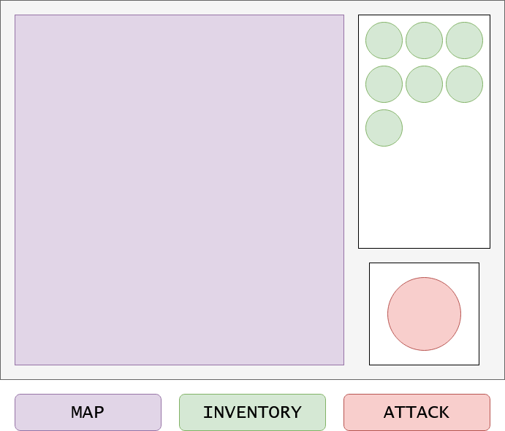

|  |  |  |
| --- | --- | --- |
| * Live updates with icons for player, enemies, and icons * When items are dropped by player, they lock to nearest character on map * When enemies are hit they flash to show impact and sound plays to give feedback to player | * Icons show items in inventory * One icon for each instance of item * Icons can be clicked and dragged to the map * When items are dropped, message is sent to unity game with details of effect and area impacted * When enemies are hit by player, there’s a chance to drop an item, which the player can tap to add to inventory | * Recharge for the tap attack * Has icon for attack * When used, recharge bar around icon drops to zero, and slowly fills up until attack can be used again * When charged, player can tap on enemies or player to do small amount of damage * When player attacks, message is sent to unity to carry out effect |